**Indira College Of Commerce**

**And Science (Wakad)**



**Hardware Management System**

**TYBCA-Sem VI**

**Year 2015-16**

* **Submitted To:**
* **Prof. ShivenduBhushan**
* **Prof. ShubhangiChavan**
* **Developed By:**
* **Devendra Ingale**
* **Dandime Hariprasad Kiran**



**Existing system**

In existing system all record maintain manually. All requirements are maintain in small register. Searching process is very difficult.

In existing system we cannot update technology daily. If any register has loss then all record are lost. For e.g. if you want to Product record from one Hundred record this process is very difficult. And in the case of if the records are loss for reason of fire, that an all so backup are not possible.

**Proposed system**

All the Compliant, employee, Product are store in a computer. All record maintain in computerized. The data store and find automatically. All the types of product get in few minutes.

Number of record store in system and search in few seconds. There is no loss of any data and records. We can give backup on the PENDRIVE, CD, RAM .there is no any wrong entry can enter if you enter wrong entry then it will show the error message.

For e.g. if you want Product record from one Hundred record this process is very time consuming. If any product occurs means missing product, fire etc then no data loss because we can give backup daily in Pen Drive, CD, and RAM.

**Objective of the proposed system**

It will increase the efficiency for e.g. avoid the wrong entry. It will increase accuracy and speed foe e.g. if you want to search the record from thousand record it will show in few seconds and it accepts only correct entry.

The system should be user friendly.for e.g. user can access the data and store the data in to the ms-access or database. The system will provide the user work with different menus and option.

**Fact finding technique**

Observation:

I can give visit to one Hardware Store and I analyze the flow of system what is in the system? Which Type of product are used?

Record review:

Customer, employee, Product, Supplier related information are store in the ms access in system all system are store in access it help to accessing easy and simple.

**Feasibility study**

Identify the user requirement. Identification of the about technology.

* Technical feasibility:

The system is developing using Java and ms­-access .The system being user friendly and it easy to searching to store the data, and retrieve the data.

* Economical feasibility:

Economical feasibility is basically a Cost benefit analysis The cost concerned is the cost for system development.

The cost of hardware, software for the system is presented economical. The benefit can be seen in form cost cutting due to fat working.

The user training is also included in cost of making the software, so it is beneficial deal.

* Operational feasibility:

Cost of implementation of the system as well as the installation that to consider in the operational feasibility after implementation of the system there is need to arrange training program.

For Users of the System .Expenditure for this system is also a part of this study.

**HARDWARE REQUIREMENTS:**

* + Pentium 4
  + 40 GB hard disk
  + 128 MB RAM
  + Keyboard
  + Mouse
  + UPS
  + 15”Monitor

**SOFTWARE REQUIREMENTS:**

* 1. Operating System:-

Windows 7

2. Software:-

Java

MS-ACCESS

The coding Part of the program is done in the Java that’s we want Java Software.

MICROSOFT ACCESS is used to store the database related to the Hardware Management System.

**Analysis and design ERD**

1

Gives purchase

Order

M

1

M

1

1

M

Pay

Bill

Generate Bill

1

1

M

M

1

1

M

1

M

Product

Purchase By

Customer

Pay

Bill

Fulfill

Order

Employee

Supplies

Handles



Supplier

M

1

1

Generates

Employee

0

Employee

Customer Information

Employee Information

Product Information

Employee Information

Customer Information

Supplier Information

Customer

Customer Information

Supplier

Employee Information

Supplier Information

0.0

**Context Level Diagram**

Employee

Employee Information

Product Information

Customer Information

Supplier Information

Customer

Customer Information

Supplier

Employee Information

Supplier Information

Employee

Employee Information

Product Information

Customer Information

Supplier Information

Customer

Customer Information

Supplier

Employee Information

Supplier Information

**Data flow diagram:**

Customer Information

Customer Information

Employee Information

Supplier Information

1.0

Employee Information

Supplier Information

Customer Information

Product Information

Supplier Information

Employee Information

Product Information

Customer

Customer

Employee

Product

Supplier

Employee

Customer

Product

Employee Information

Customer Information

Product Information

2.0

Sales

Supplier Information

Product Information

Employee

Employee Information

Customer Information

Product

Product Information

Customer Information

Employee Information

**Table**

Customer

|  |  |  |  |  |
| --- | --- | --- | --- | --- |
| ***Sr.No*** | ***Field Name*** | ***Data Type*** | ***Width*** | ***Constraint*** |
| 1 | Customer_Id | Number | 5 | PK |
| 2 | Customer_Name | Text | 10 | Not Null |
| 3 | Customer_Address | Text | 25 | Not Null |
| 4 | Customer_Contact | Number | 15 | Not Null |
| 5 | Customer_Email | Text | 12 | Not Null |
| 6 | Gender | Text | 15 | Not Null |
| 7 | DateOfBirth | Date/Time | 15 | Not Null |

**Employee Details:**

|  |  |  |  |  |
| --- | --- | --- | --- | --- |
| ***Sr.No*** | ***Field Name*** | ***Data Type*** | ***Width*** | ***Constraint*** |
| 1 | Employee_Id | Number | 5 | PK |
| 2 | Employee_Name | Text | 10 | Not Null |
| 3 | Employee_Address | Number | 25 | Not Null |
| 4 | Employee_Email | Text | 15 | Not Null |
| 5 | Employee_Contact | Number | 12 | Not Null |
| 6 | Gender | Text | 15 | Not Null |
| 7 | DateOfBirth | Date/Time | 15 | Not Null |
| 8 | Designation | Text | 20 | Not Null |
| 9 | DateOfJoin | Date/Time | 20 | Not Null |

|  |  |  |  |  |
| --- | --- | --- | --- | --- |
| ***Sr.No*** | ***Field Name*** | ***Data Type*** | ***Width*** | ***Constraint*** |
| 1 | Supplier_ID | Number | 5 | PK |
| 2 | Supplier_Name | Text | 10 | Not Null |
| 3 | Supplier_Address | Text | 25 | Not Null |
| 4 | Supplier_Email | Text | 15 | Not Null |
| 5 | Supplier_Contact | Number | 12 | Not Null |
| 6 | Supplier_Gender | Text | 15 | Not Null |

Supplier

|  |  |  |  |  |
| --- | --- | --- | --- | --- |
| ***Sr.No*** | ***Field Name*** | ***Data Type*** | ***Width*** | ***Constraint*** |
| 1 | Product_ID | Number | 5 | PK |
| 2 | Product_Name | Text | 10 | Not Null |
| 3 | Product_Details | Text | 25 | Not Null |
| 4 | Product_Quantity | Number | 5 | Not Null |
| 5 | Rate | Number | 10 | Not Null |

Product

|  |  |  |  |  |
| --- | --- | --- | --- | --- |
| ***Sr.No*** | ***Field Name*** | ***Data Type*** | ***Width*** | ***Constraint*** |
| 1 | Order_no | Number | 5 | PK |
| 2 | Purchase_Quantity | Number | 10 | Not Null |
| 3 | Purchase_Price | Number | 25 | Not Null |
| 4 | Employee_name | Text | 15 | Not Null |
| 5 | Employee_Contact | Number | 12 | Not Null |
| 6 | Purchase_Date | Date/Time | 15 | Not Null |
| 7 | Total Bill | Number | 15 | Not Null |

Order Table

Bill

|  |  |  |  |  |
| --- | --- | --- | --- | --- |
| ***Sr.No*** | ***Field Name*** | ***Data Type*** | ***Width*** | ***Constraint*** |
| 1 | Bill_ID | Number | 5 | PK |
| 2 | Bill_Amount | Number | 10 | Not Null |
| 3 | Customer_name | Text | 25 | Not Null |
| 4 | Customer_Address | Text | 15 | Not Null |
| 5 | Customer_Contact | Number | 12 | Not Null |
| 6 | Product_Details | Text | 15 | Not Null |
| 7 | Product_Quantity | Number | 15 | Not Null |
| 8 | Rate | Number | 15 | Not Null |
| 9 | Date | Date/Time | 15 | Not Null |

**Data Dictionary**

|  |  |  |  |  |  |
| --- | --- | --- | --- | --- | --- |
| **Sr.no** | **Field Name** | **Data Type** | **Width** | **Constraint** | **Table Name** |
| 1 | Bill_amount | Number | 10 | Not Null | Bill |
| 2 | Bill_Id | Number | 15 | PK | Bill |
| 3 | Customer_Address | Text | 15 | Not Null | Customer |
| 4 | Customer_Address | Text | 19 | Not Null | Customer |
| 5 | Customer_Contact | Number | 19 | Not Null | Customer |
| 6 | Customer_Contact | Number | 19 | Not Null | Customer |
| 7 | Customer_Dateofbirth | Date/Time | 10 | Not Null | Customer |
| 8 | Customer_Email | Text | 20 | Not Null | Customer |
| 9 | Customer_Gender | Text | 10 | Not Null | Customer |
| 10 | Customer_ID | Number | 20 | PK | Customer |
| 11 | Customer_ID | Number | 20 | Forgin Key | Bill |
| 12 | Customer_Name | Text | 10 | Not Null | bill |
| 13 | Employee_Address | Text | 15 | Not Null | Employee |
| 14 | Employee_Contact | Number | 15 | Not Null | Employee |
| 15 | Employee_Contact | Number | 20 | Not Null | Employee |
| 16 | Employee_DateOfBirth | Date/Time | 20 | Not Null | Employee |
| 17 | Employee_Designation | Text | 20 | Not Null | Employee |
| 18 | Employee_E-mail | Text | 20 | Not Null | Employee |
| 19 | Employee_E-mail | Text | 20 | Not Null | Employee |
| 20 | Employee_ID | Number | 20 | PK | Employee |
| 21 | Employee_Name | Text | 15 | Not Null | Employee |
| 22 | Employee_Name | Text | 30 | Not Null | Employee |
| 23 | Order_number | Number | 10 | PK | Purchase |
| 24 | Password | Text | 20 | Not Null | Login |
| 25 | Product_Details | Text | 20 | Not Null | Product |
| 26 | Product_Details | Text | 20 | Not Null | Bill |
| 27 | Product_Id | Number | 20 | PK | Product |
| 28 | Product_Name | Text | 20 | Not Null | Product |
| 29 | Product_Quanitity | Number | 20 | Not Null | Product |
| 30 | Product_Quantity | Number | 20 | Not Null | Bill |
| 31 | Purchase_Date | Date/Time | 10 | Not Null | Purchase |
| 32 | Purchase_Price | Number | 20 | Not Null | Purchase |
| 33 | Purchase_Qunatity | Number | 15 | Not Null | Purchase |
| 34 | Supplier_Address | Text | 15 | Not Null | Supplier |
| 35 | Supplier_contact | Number | 10 | Not Null | Supplier |
| 36 | Supplier_DateofBirth | Date/Time | 15 | Not Null | Supplier |
| 37 | Supplier_E-mail | Text | 10 | Not Null | Supplier |
| 38 | Supplier_Gender | Text | 30 | Not Null | Supplier |
| 39 | Supplier_Id | Number | 15 | PK | Supplier |
| 40 | Supplier_Name | Text | 20 | Not Null | Supplier |
| 41 | UserName | Text | 30 | Not Null | Login |

Screen layout:

Admin Input Screen

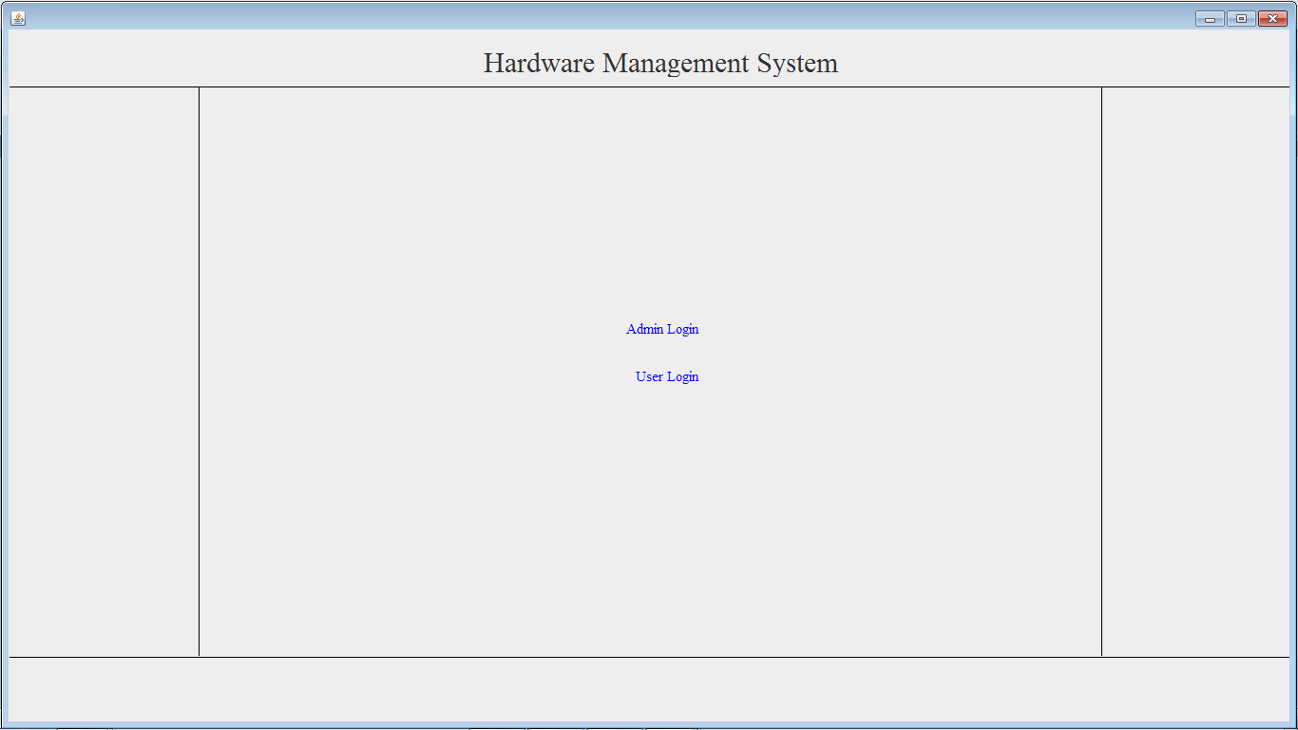

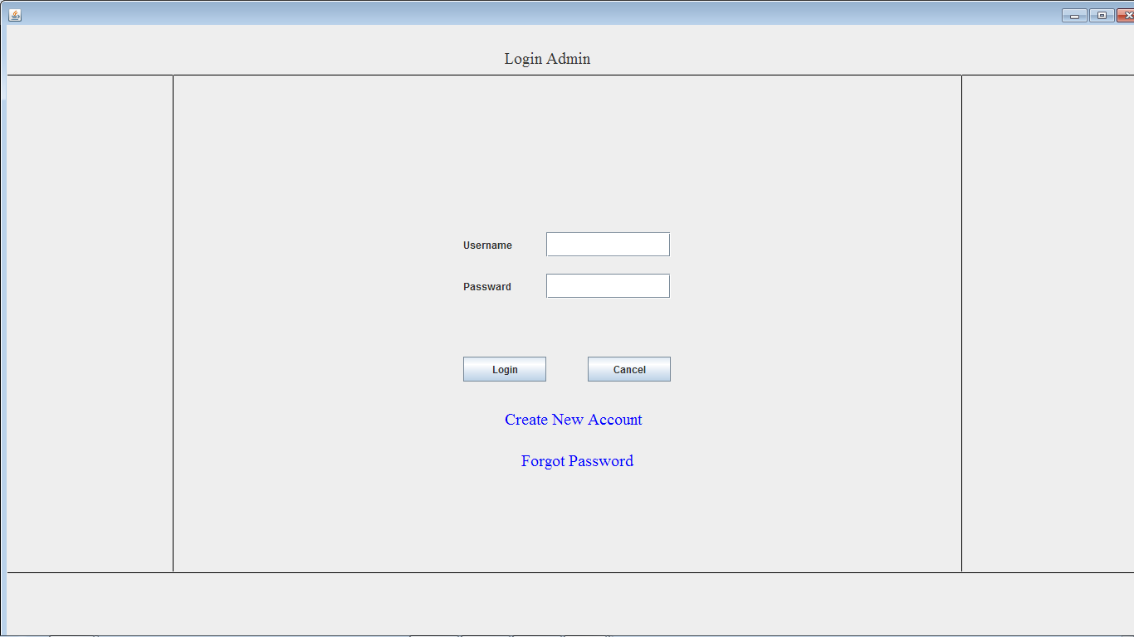

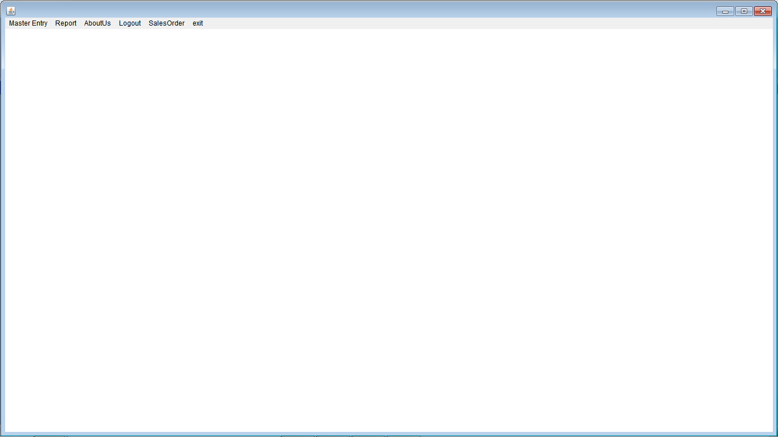

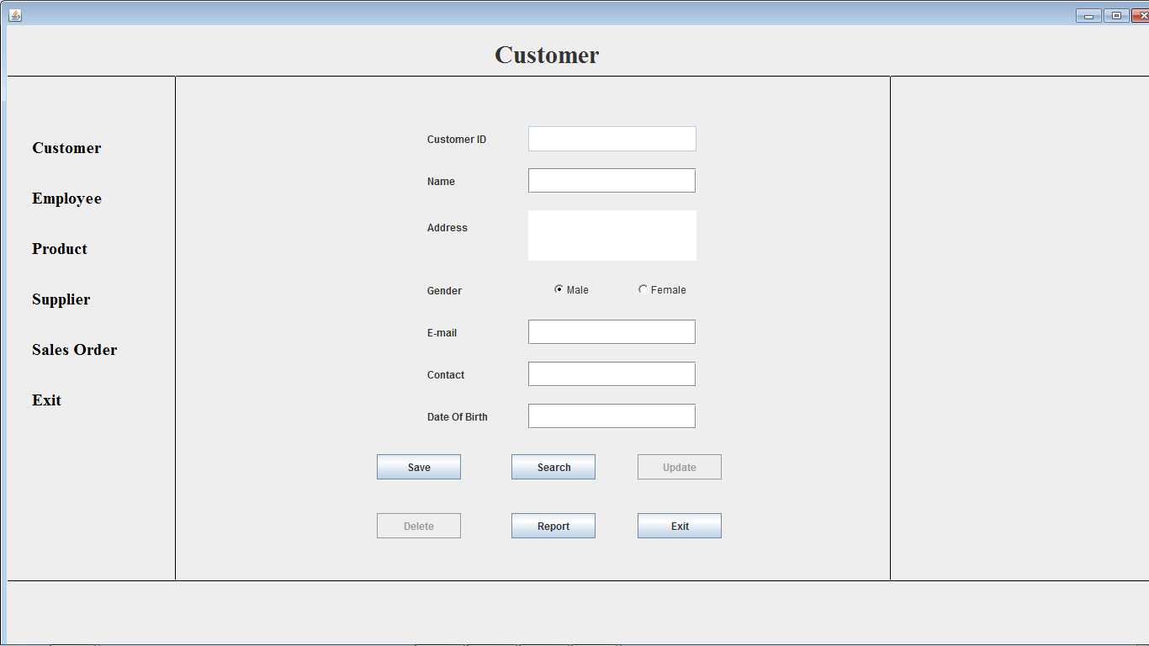

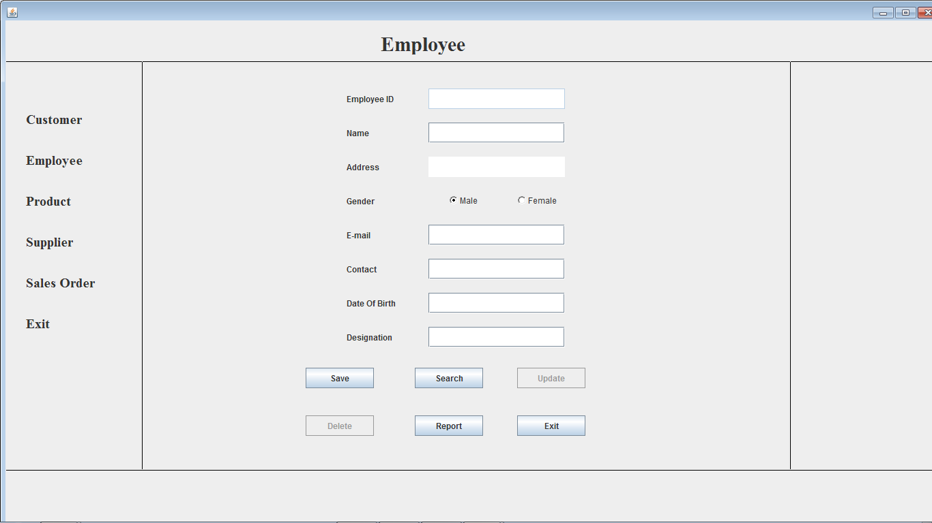

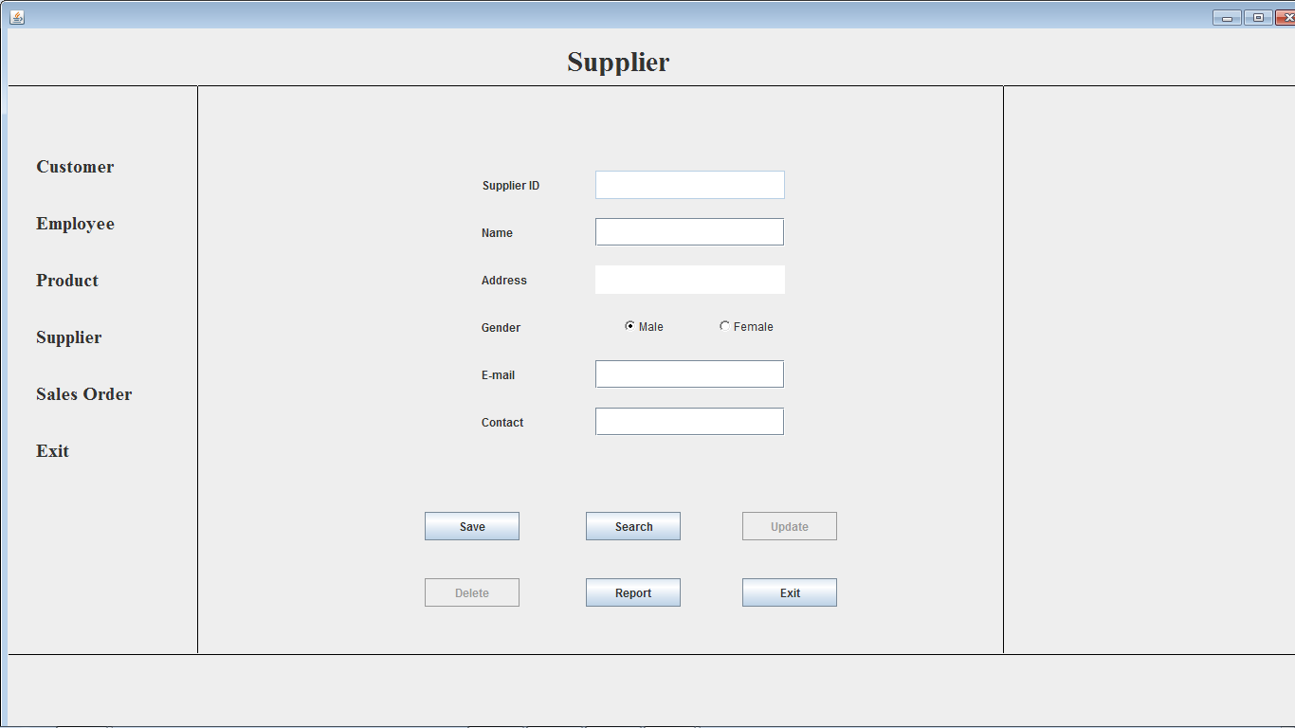

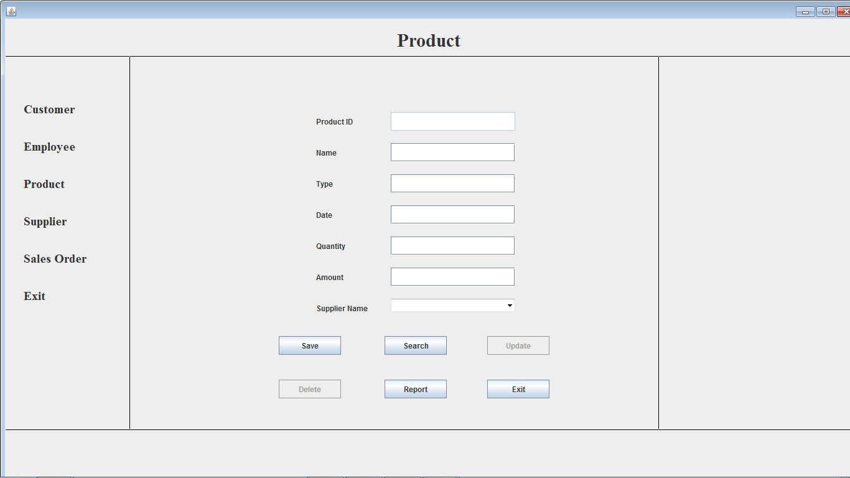

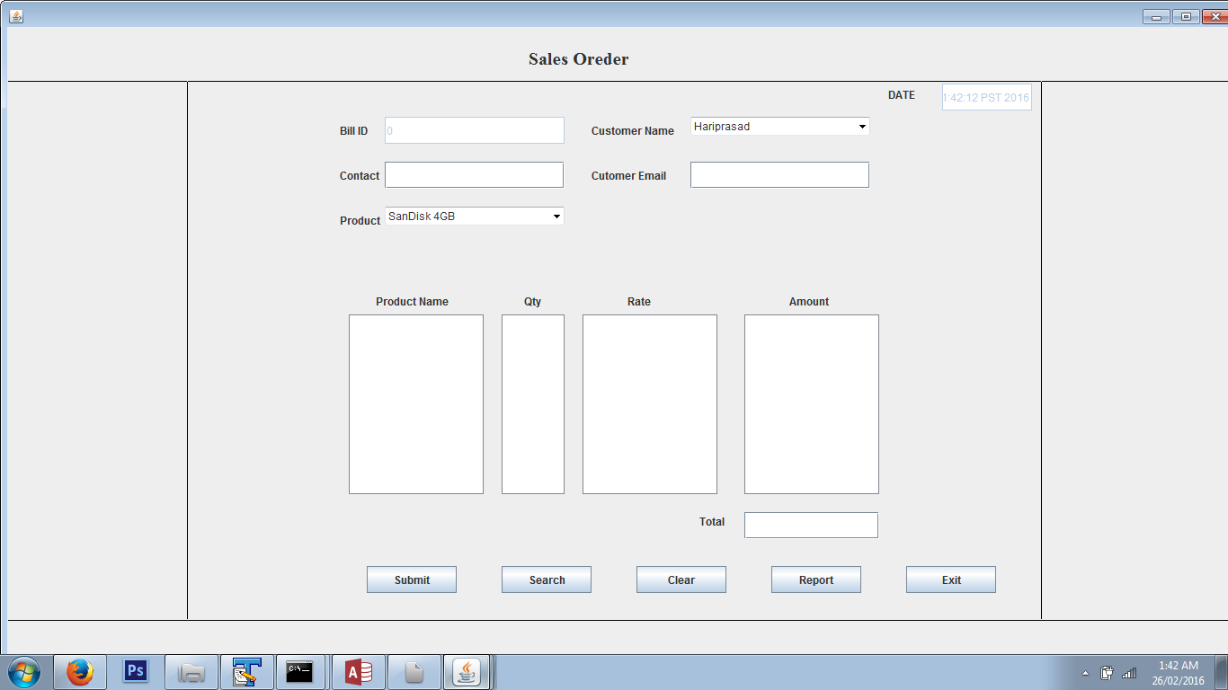

Admin Output Screen:

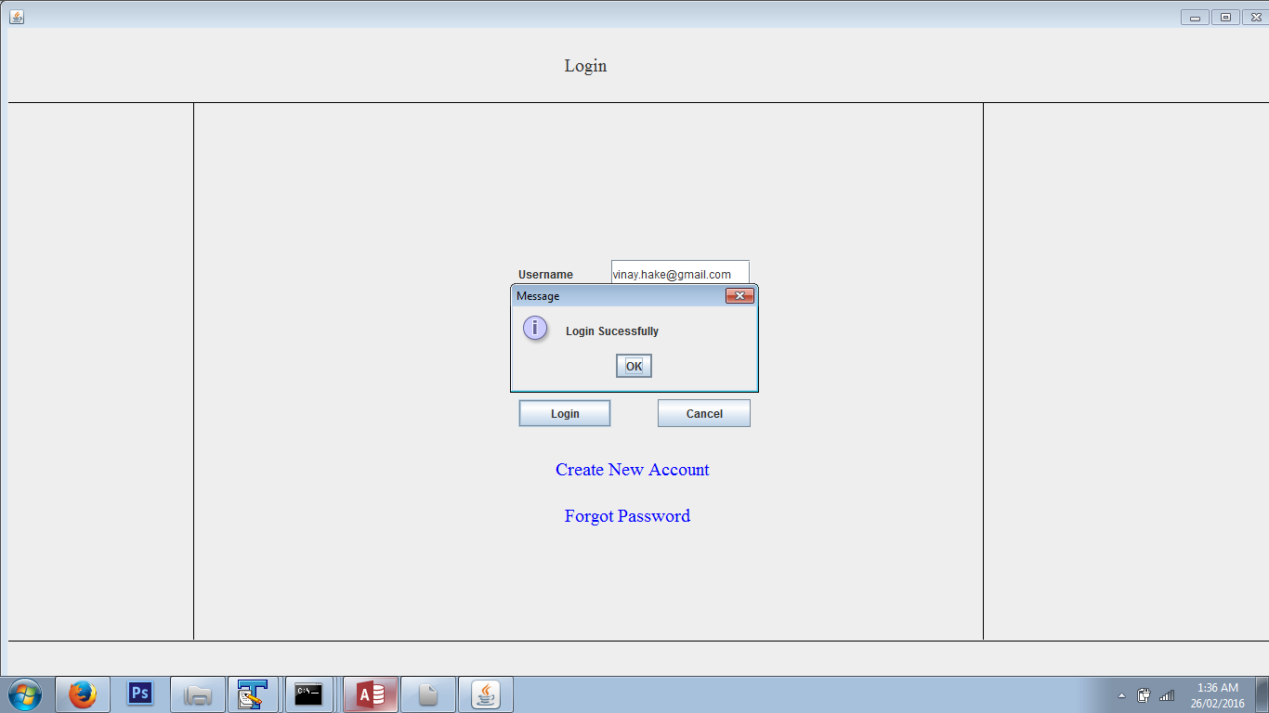

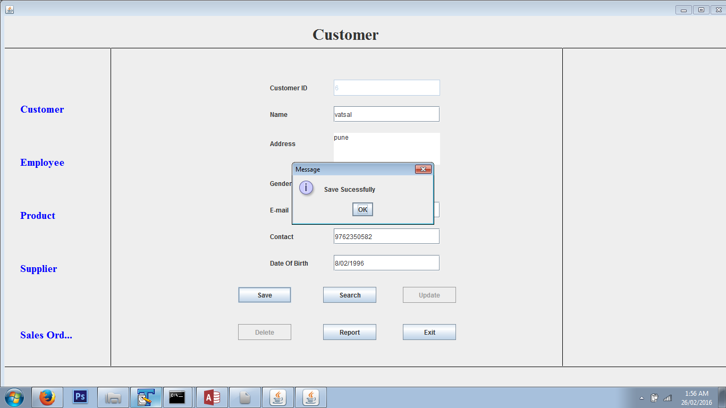

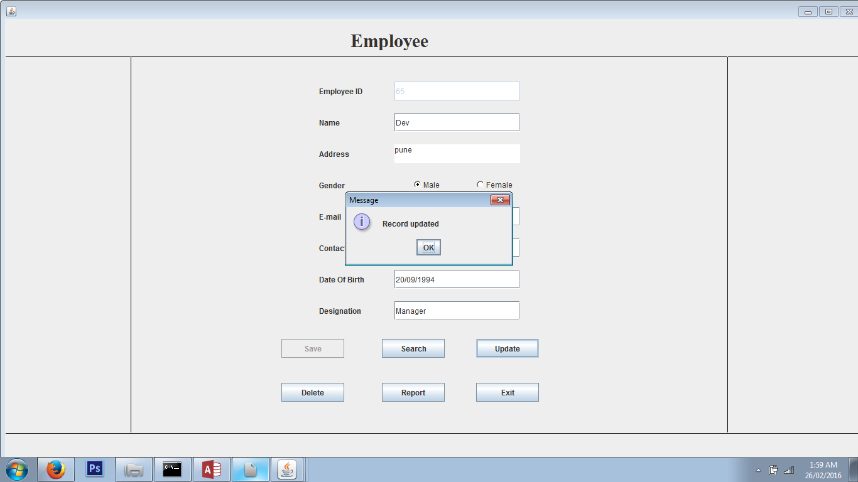

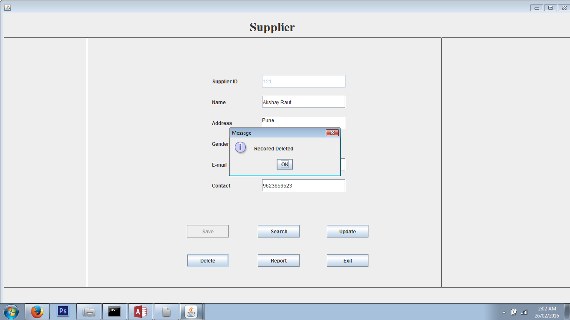

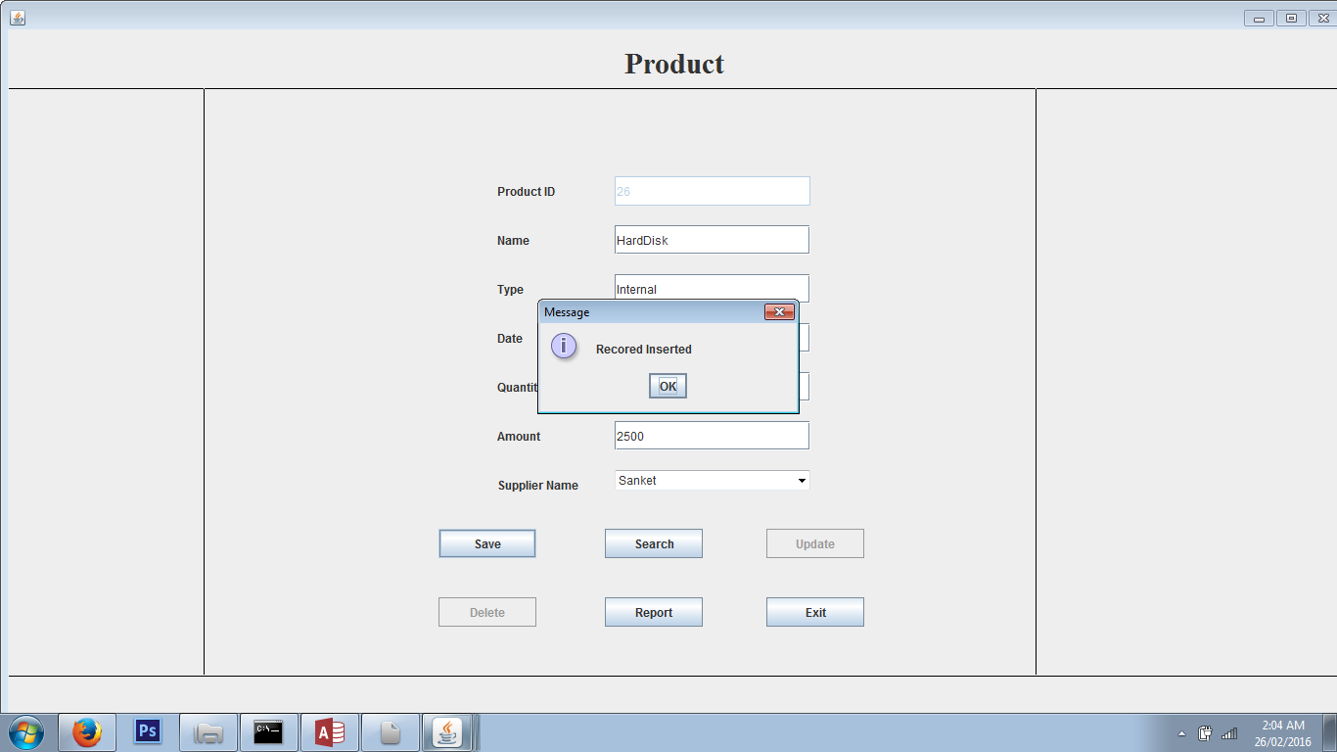

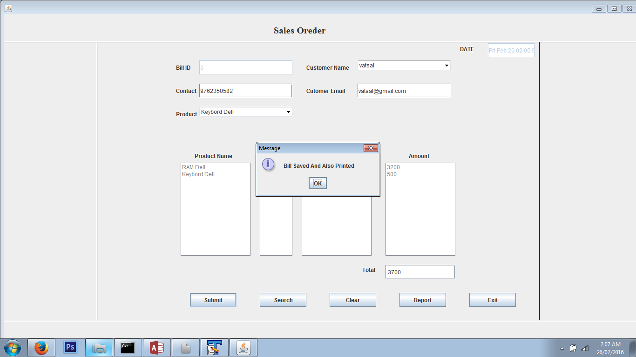

User Input Screen

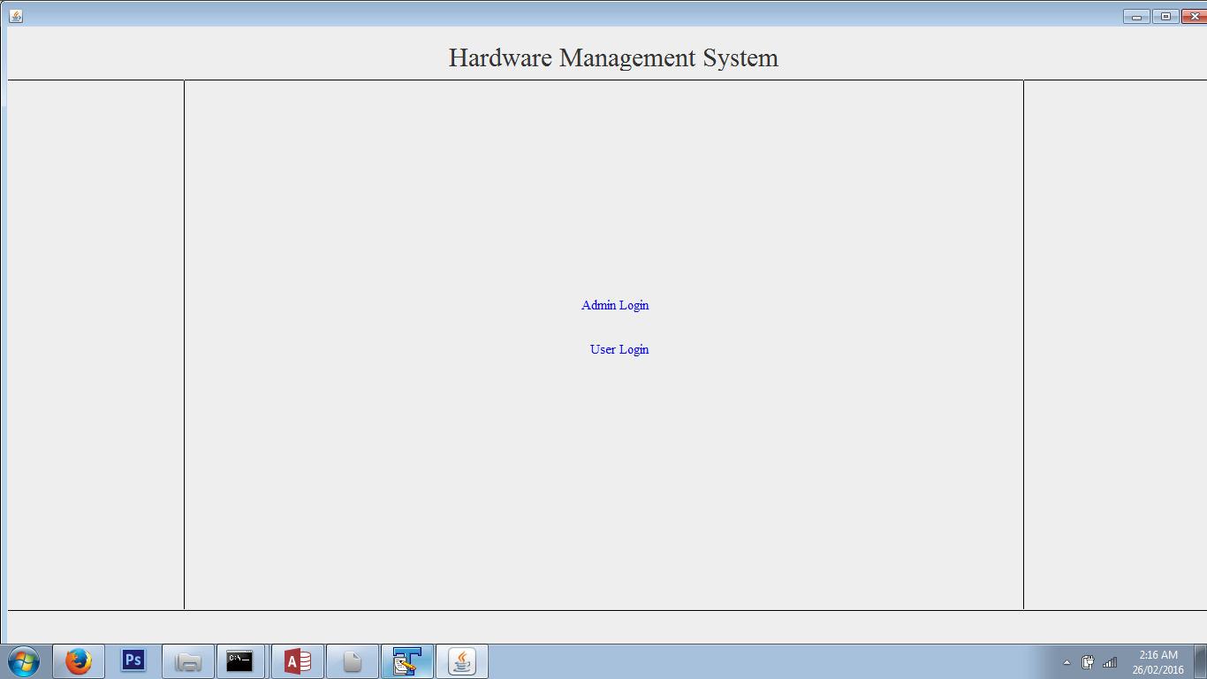

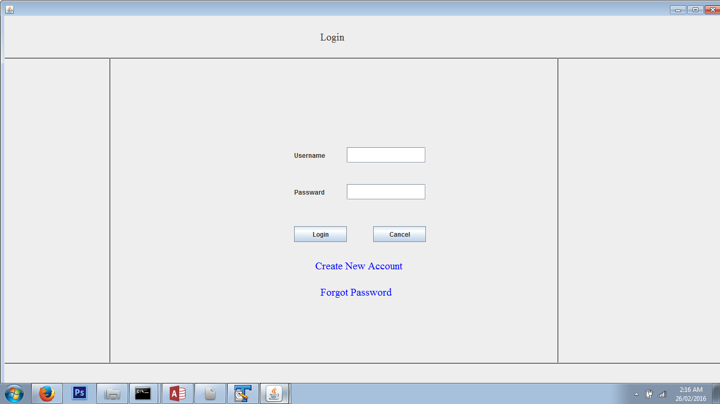

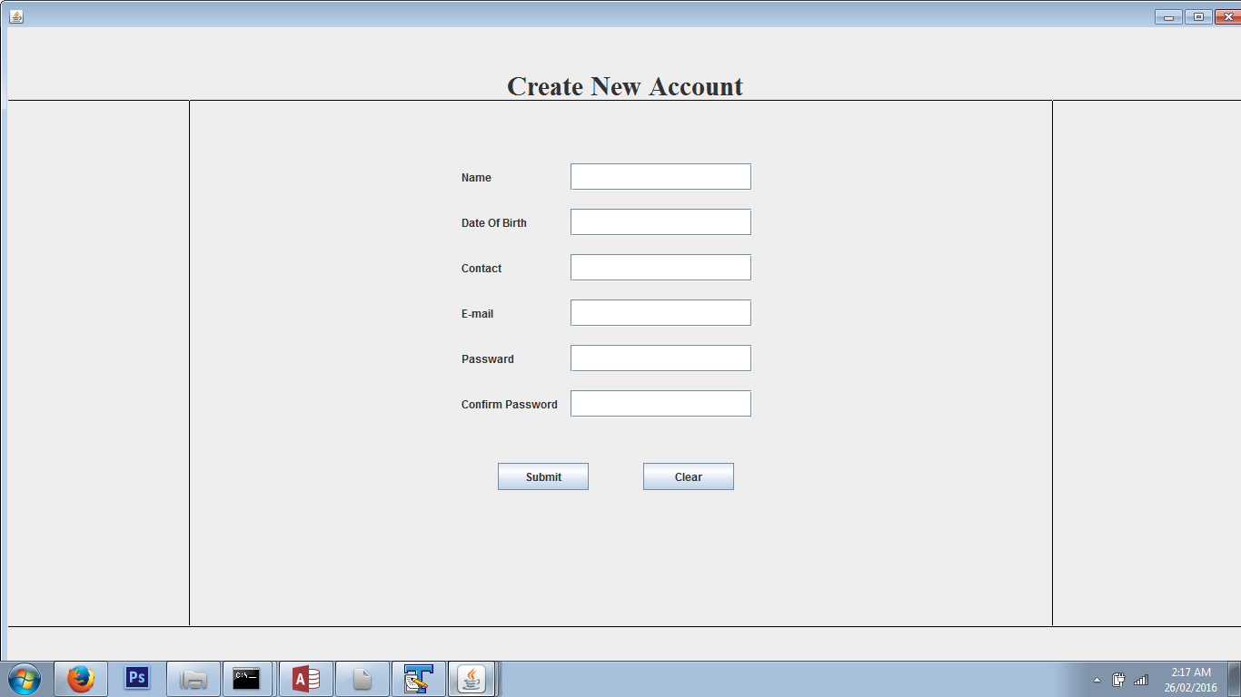

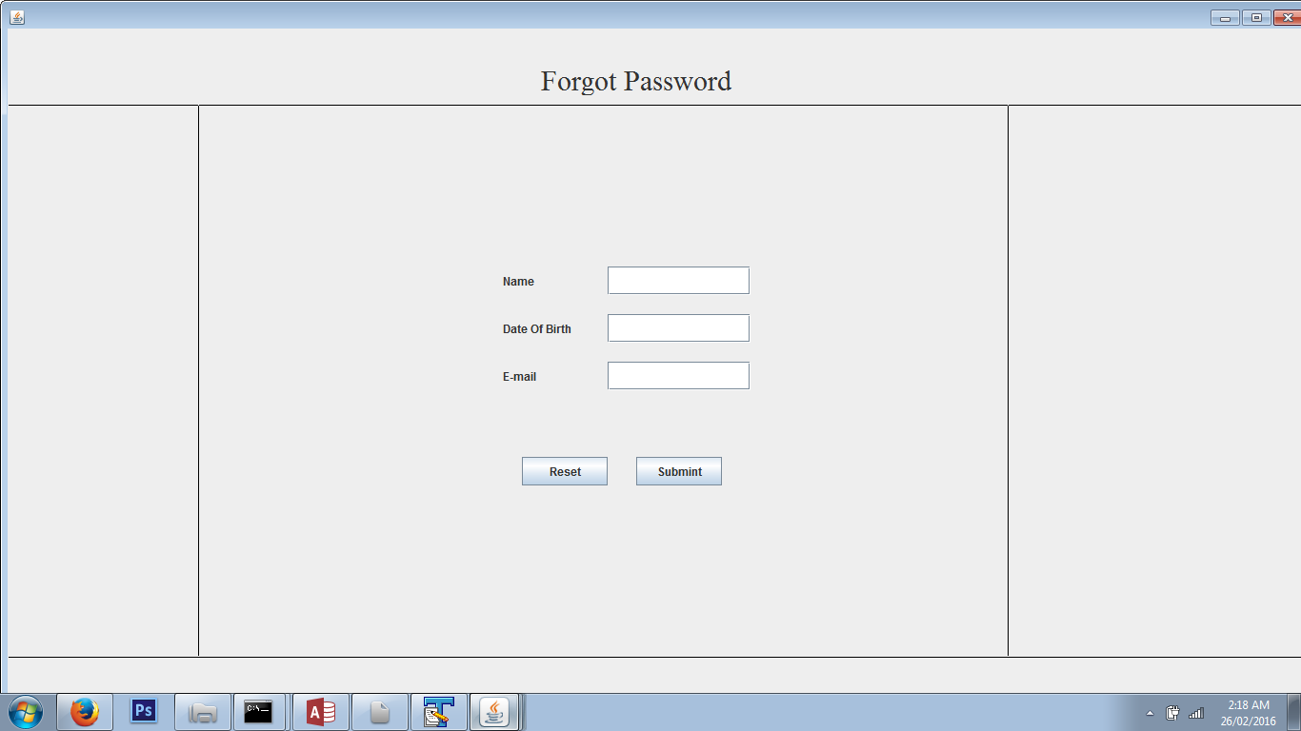

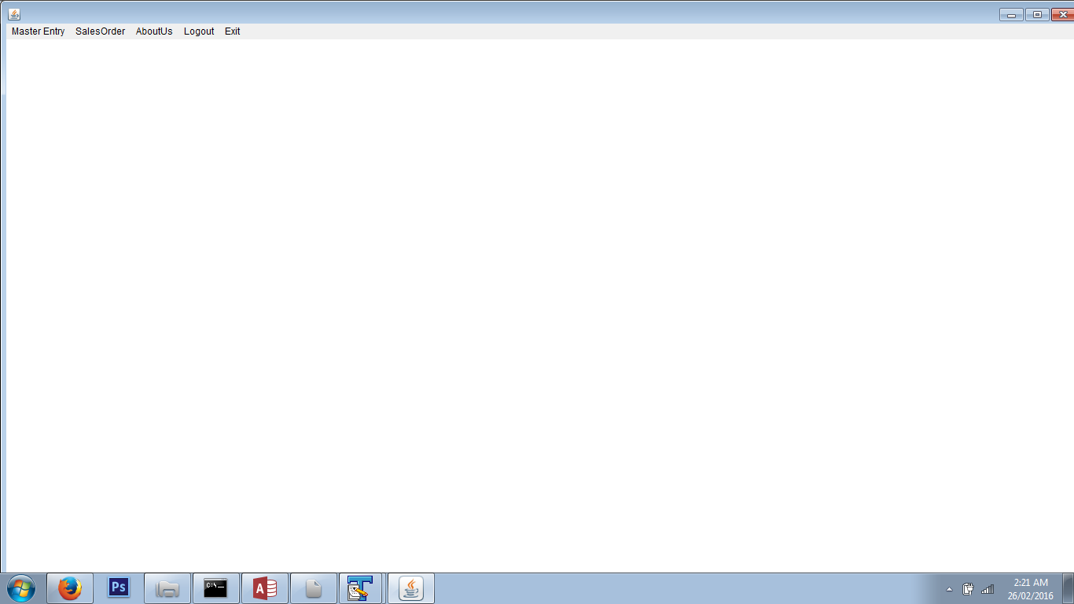

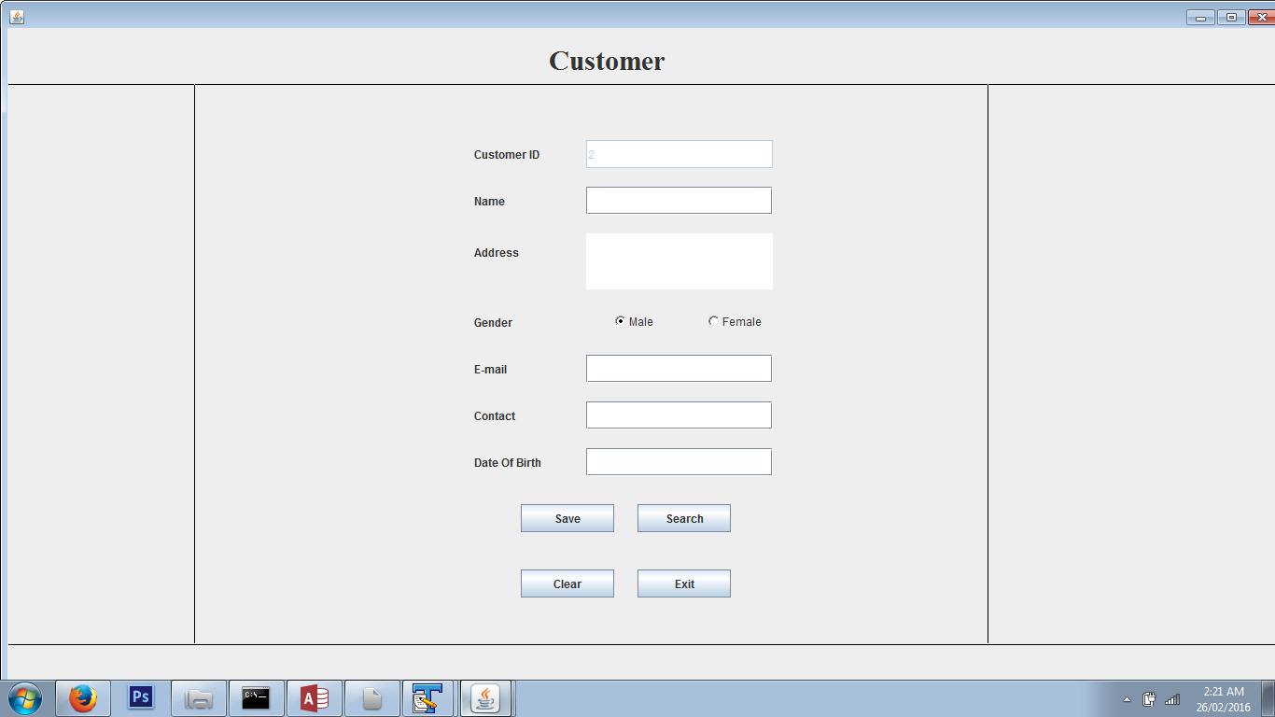

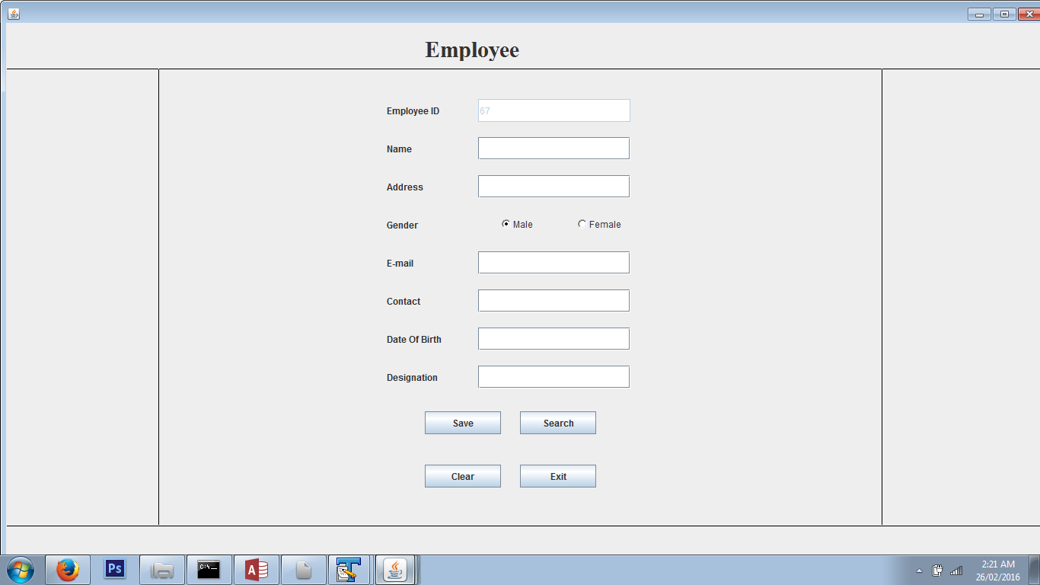

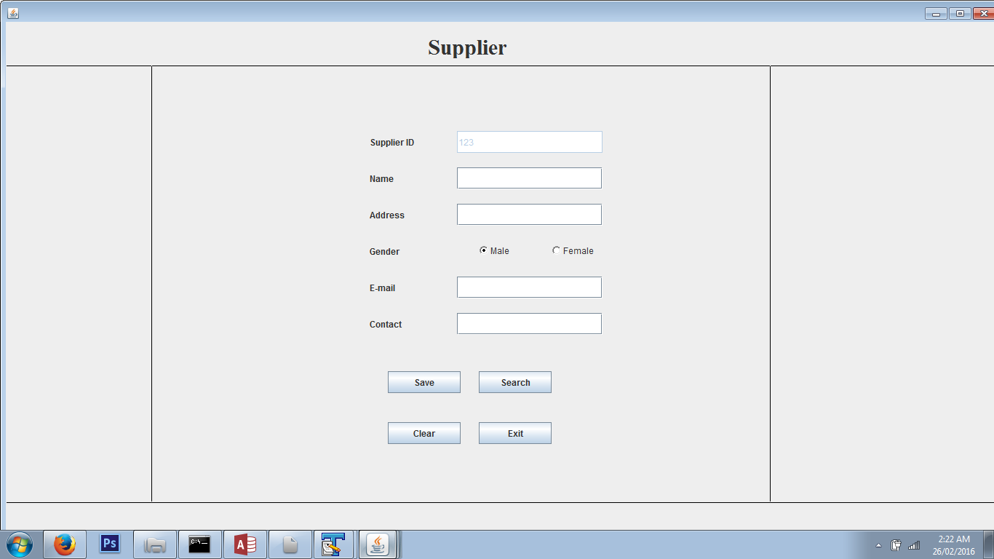

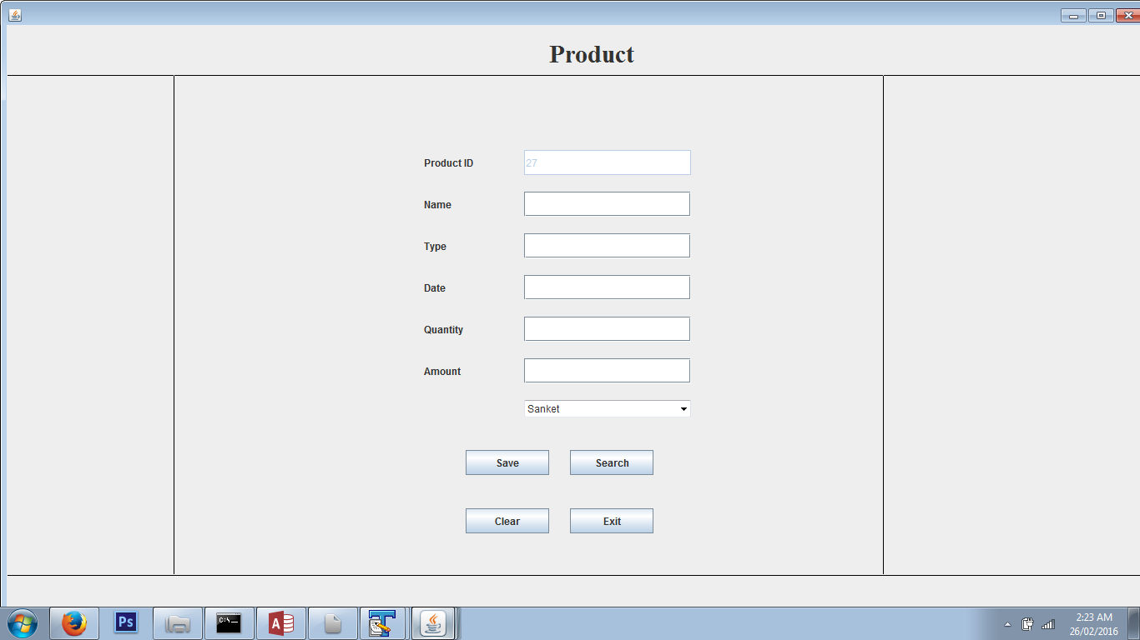

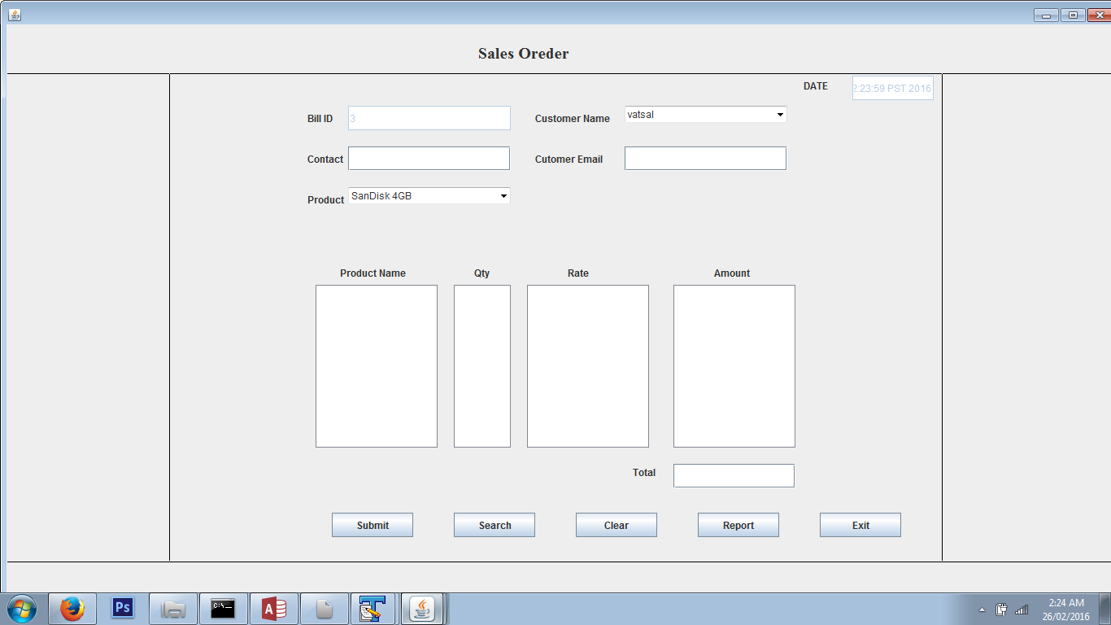

User Output Screen

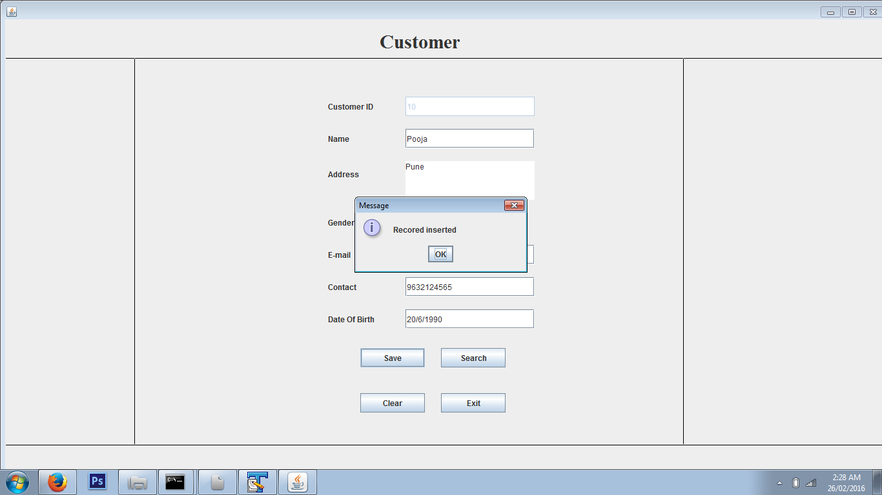

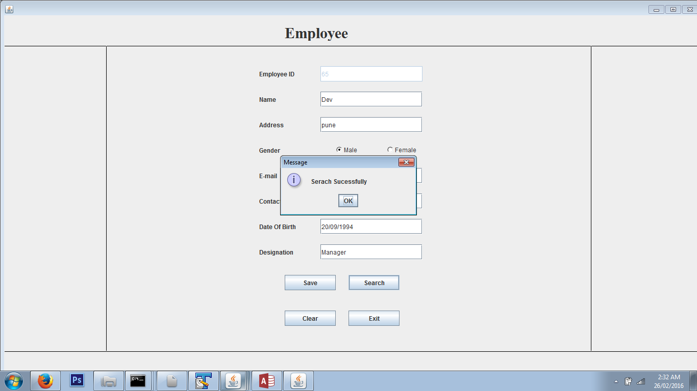

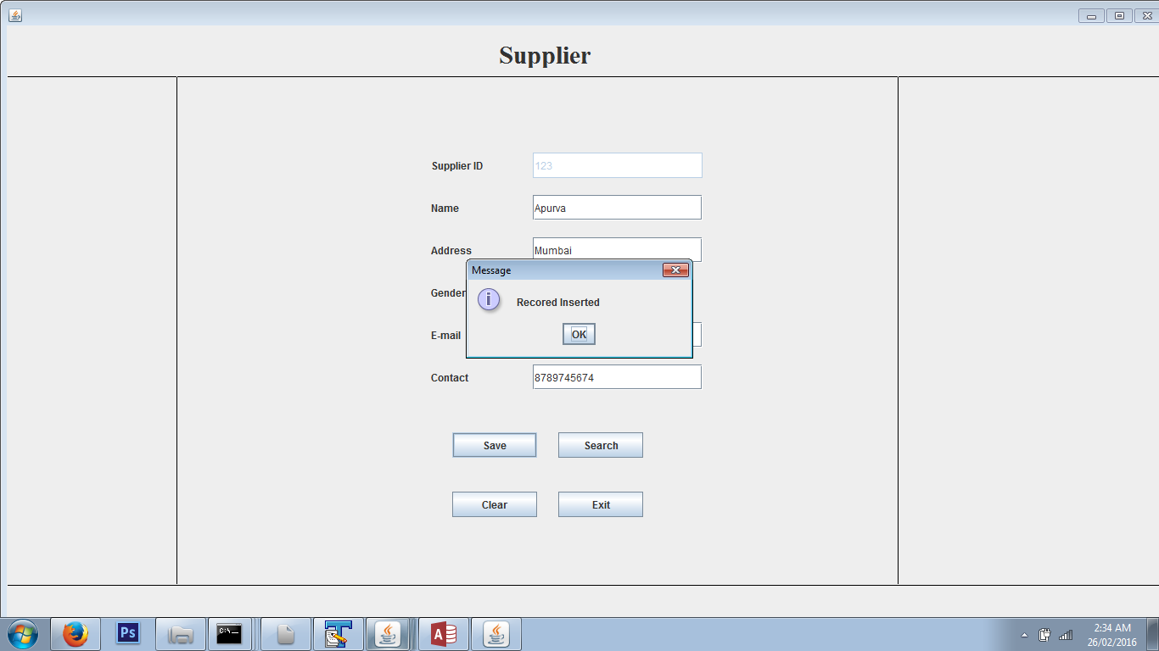

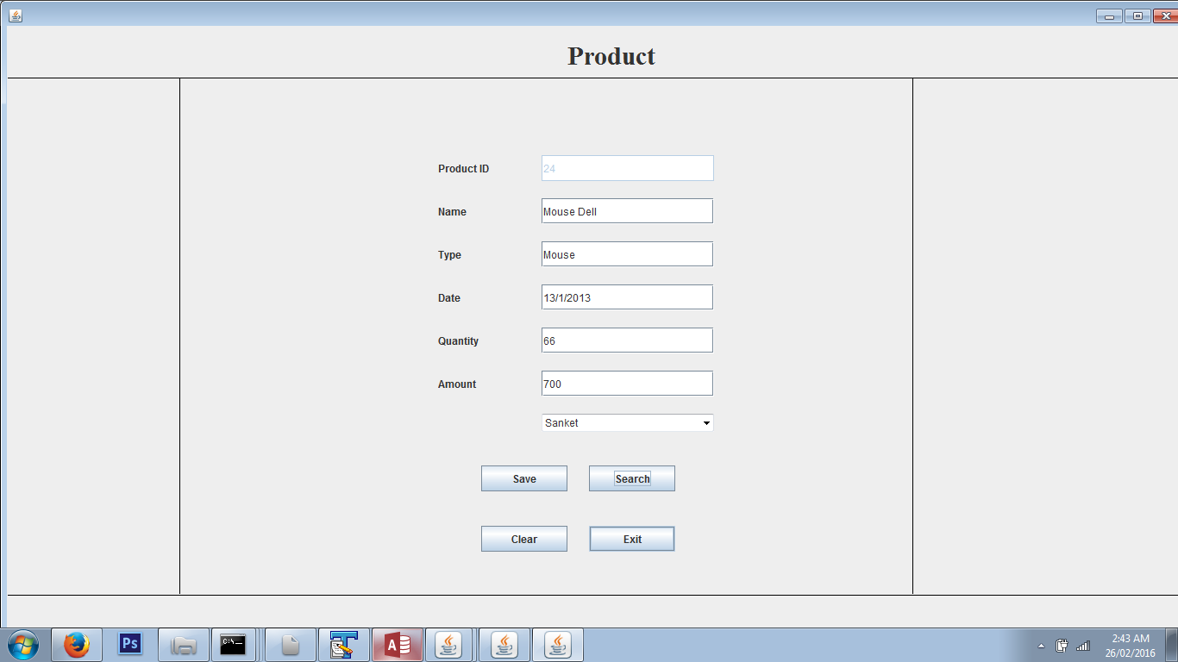

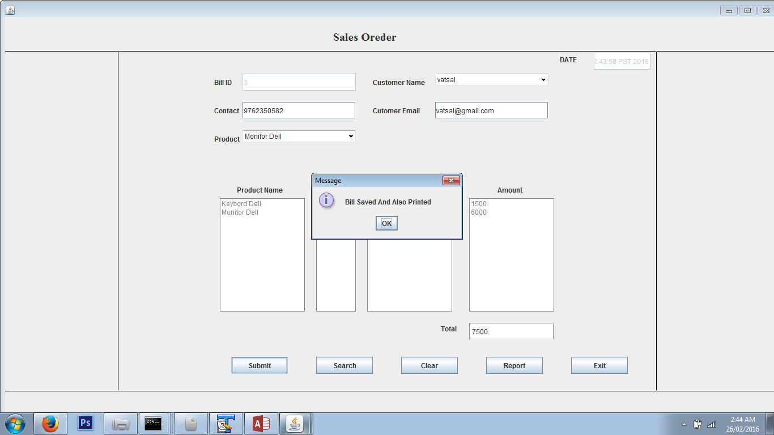

**LIMITATIONS**

* Not suitable incase if the customer wants to extend the period to stay at the hotel since the advance booking has been provided.
* Can’t use or keep track of extra facilities such as Gym etc.
* Transaction should be only be manual i.e. not possible by post or say the online transaction.

**CONCLUSION**

* The project “Crime Management System” has been successfully completed.
* The goal of system is feature problems are solved .The computerized system.
* Can save time or easily convince the client .To maintain records of this software.
* For the developing the group project hence we can understands the Importance of Teamworks.
* Also we understand the process of IT industry that how to handled the project and how in arrange with an proper Schedule.

**BIBLOGRAPHY**

* List of Books Referred  
   1. CORE JAVA (BCA)  
     
   2. Black Book (JAVA)
* Online Help:

Sun Micro System.

Google.